Appendix

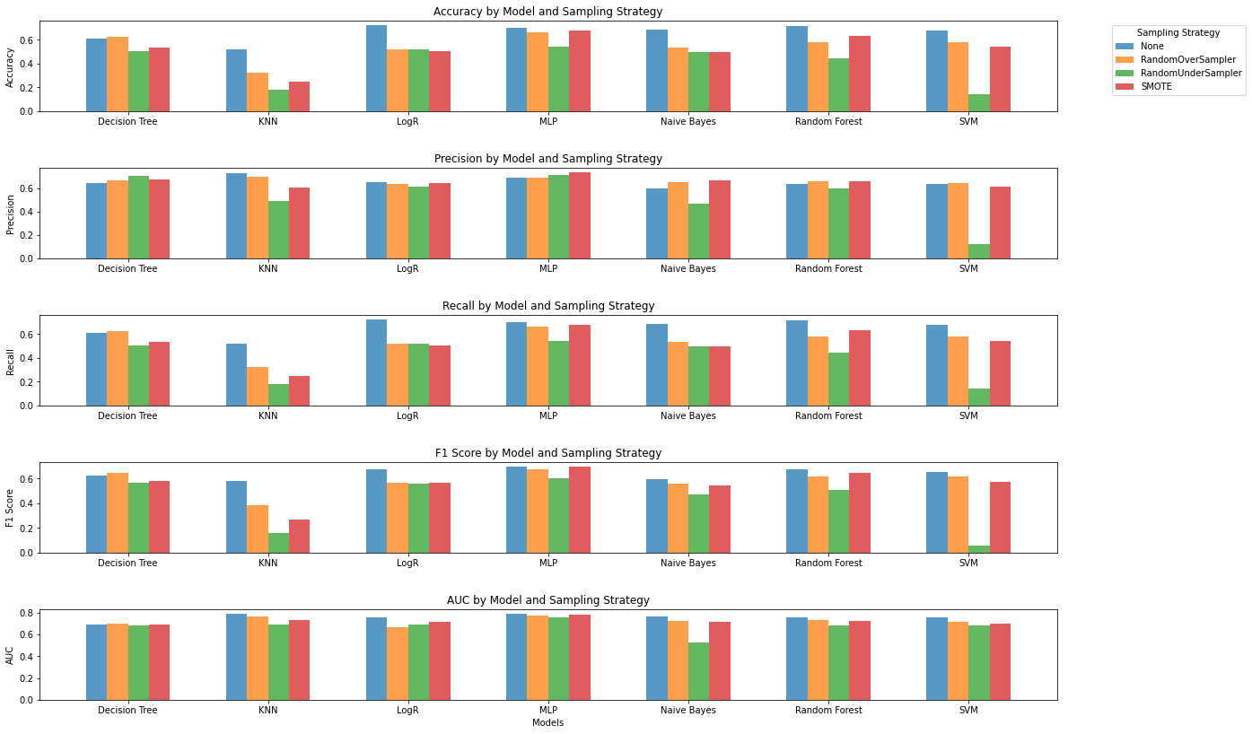

Figure 1. Results of experiment 1 when using different sampling techniques

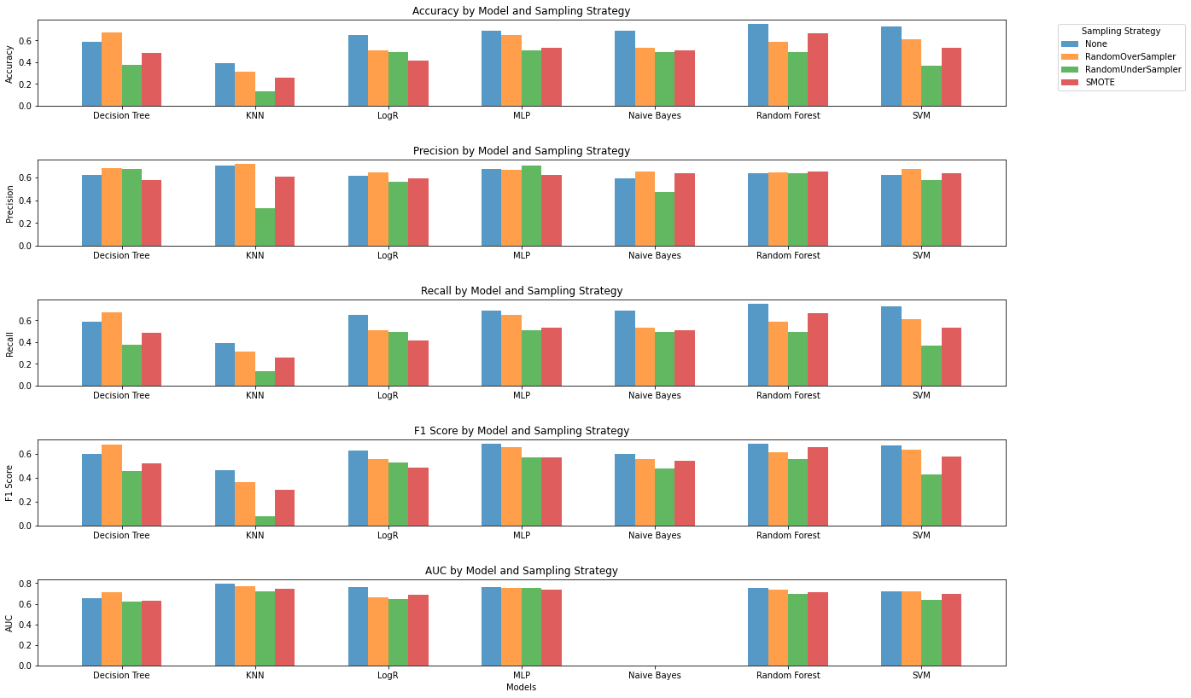

Figure 2. Results of experiment 2 when using different sampling techniques

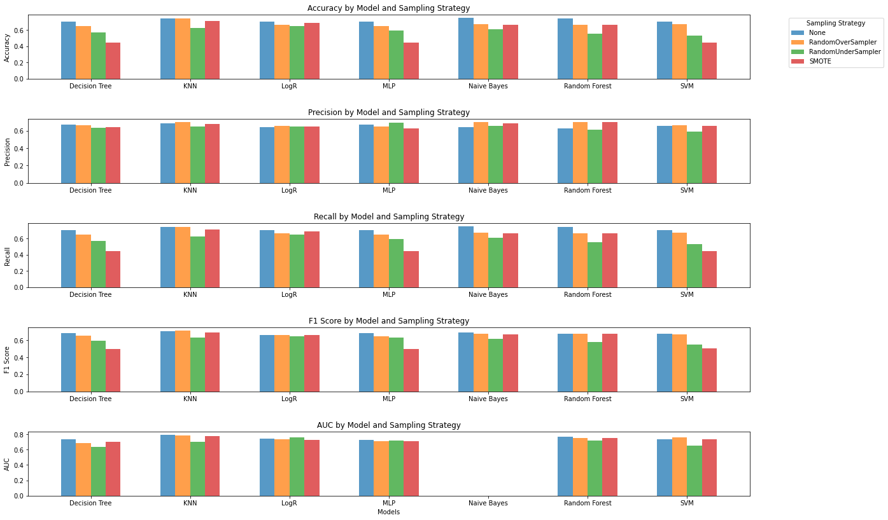

Figure 3. Results of experiment 3 when using different sampling techniques